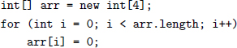
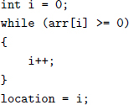
(A)
always.
(B)
never.
(C)
whenever
arr
contains at least one negative integer.
(D)
whenever
arr
contains at least one nonnegative integer.
(E)
whenever
arr
contains no negative integers.
1.
Which of the following correctly initializes an array
arr
to contain
four elements each with value
0?
I.
int[] arr = {0, 0, 0, 0};
II.
int[] arr = new int[4];
III.
(A)
I only
(B)
III only
(C)
I and III only
(D)
II and III only
(E)
I, II, and III
2.
The following program segment is intended to find the index of the
first negative integer in
arr[0]
…
arr[N-1]
, where
arr
is an array
of
N
integers.
This segment will work as intended
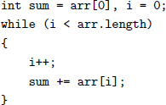
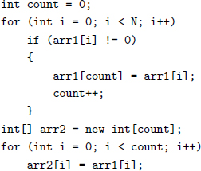
3.
Refer to the following code segment. You may assume that
arr
is
an array of
int
values.
Which of the following will be the result of executing the segment?
(A)
Sum of
arr[0], arr[1]
, …,
arr[arr.length-1]
will be
stored in
sum
.
(B)
Sum of
arr[1], arr[2]
, …,
arr[arr.length-1]
will be
stored in
sum
.
(C)
Sum
of
arr[0], arr[1]
,
…,
arr[arr.length]

will
be
stored in
sum
.
(D)
An infinite loop will occur.
(E)
A run-time error will occur.
4.
Refer to the following code segment. You may assume that array
arr1
contains elements
arr1[0], arr1[1]
, …,
arr1[N-1]
, where
N
=
arr1.length
.
If array
arr1
initially contains the elements 0, 6, 0, 4, 0, 0, 2 in this
order, what will
arr2
contain after execution of the code segment?
(A)
6, 4, 2
(B)
0, 0, 0, 0, 6, 4, 2
(C)
6, 4, 2, 4, 0, 0, 2
(D)
0, 6, 0, 4, 0, 0, 2
(E)
6, 4, 2, 0, 0, 0, 0
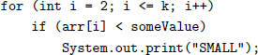
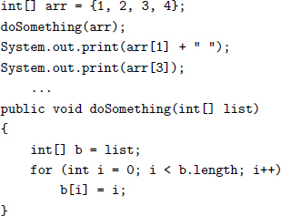
5.
Consider this program segment.
What is the maximum number of times that
SMALL
can be printed?
(A)
0
(B)
1
(C)
k - 1
(D)
k - 2
(E)
k
6.
What will be output from the following code segment, assuming it
is in the same class as the
doSomething
method?
(A)
0 0
(B)
2 4
(C)
1 3
(D)
0 2
(E)
0 3
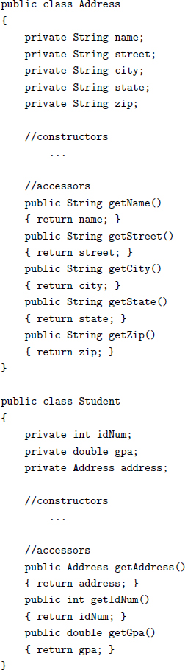
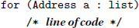
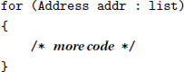
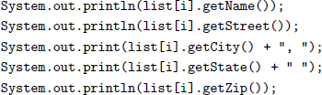
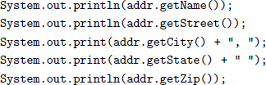
9.
A client method has this declaration, followed by code to initialize
the list.
Address[] list = new Address[100];
Here is a code segment to generate a list of names only.
Which is a correct
/*
line of code
*/?
(A)
System.out.println(Address[i].getName());
(B)
System.out.println(list[i].getName());
(C)
System.out.println(a[i].getName());
(D)
System.out.println(a.getName());
(E)
System.out.println(list.getName());
10.
The following code segment is to print out a list of addresses.
Which is a correct replacement for
/*
more code
*/?
I.
II.
III.
System.out.println(addr);
(A)
I only
(B)
II only
(C)
III only
(D)
I and II only
(E)
I, II, and III
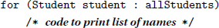
11.
A client method has this declaration.
Here is a code segment to generate a list of
Student
names only.
(You may assume that
allStudents
has been initialized.)
Which is a correct replacement for
/*
code to print list of names
*/?
(A)
System.out.println(allStudents.getName());
(B)
System.out.println(student.getName());
(C)
System.out.println(student.getAddress().getName());
(D)
System.out.println(allStudents.getAddress().getNam
e());
(E)
System.out.println(student[i].getAddress().getName(
));
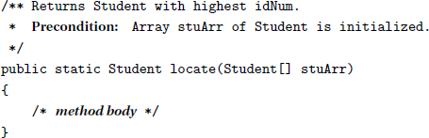
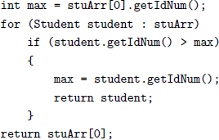
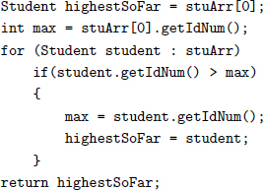
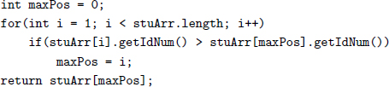
12.
Here is a method that locates the
Student
with the highest
idNum
.
Which of the following could replace
/*
method body
*/
so that
the method works as intended?
I.
II.
III.
(A)
I only
(B)
II only
(C)
III only
(D)
I and III only
(E)
II and III only
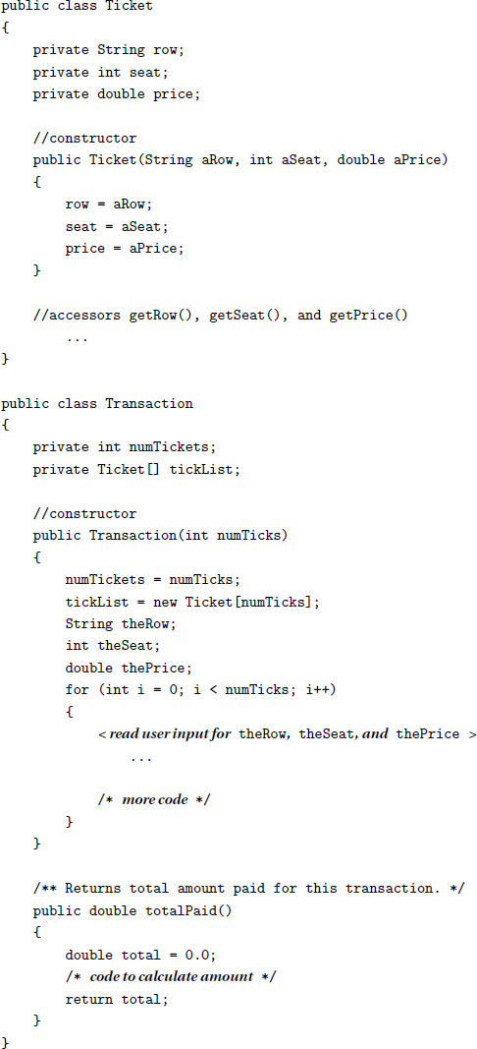
Questions 13–15 refer to the
Ticket
and
Transaction
classes below.
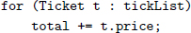
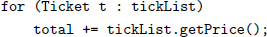
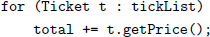
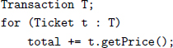
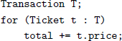
13.
Which of the following correctly replaces
/*
more code
*/
in the
Transaction
constructor to initialize the
tickList
array?
(A)
tickList[i]
=
new
Ticket(getRow(),
getSeat(),
getPrice());
(B)
tickList[i]
=
new
Ticket(theRow,
theSeat,
thePrice);
(C)
tickList[i] = new tickList(getRow(), getSeat(),
getPrice());
(D)
tickList[i]
=
new
tickList(theRow,
theSeat,
thePrice);
(E)
tickList[i] = new tickList(numTicks);
14.
Which represents correct
/*
code to calculate amount
*/
in the
totalPaid
method?
(A)
(B)
(C)
(D)
(E)
15.
Suppose it is necessary to keep a list of all ticket transactions.
Assuming
that
there
are
NUMSALES

transactions,
a
suitable
declaration would be
(A)
Transaction[]
listOfSales
=
new
Transaction[NUMSALES];
(B)
Transaction[] listOfSales = new Ticket[NUMSALES];
(C)
Ticket[] listOfSales = new Transaction[NUMSALES];
(D)
Ticket[] listOfSales = new Ticket[NUMSALES];
(E)
Transaction[] Ticket = new listOfSales[NUMSALES];
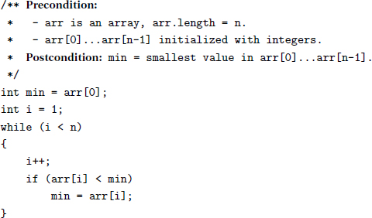
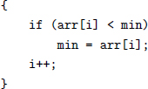
16.
The following code fragment is intended to find the smallest value
in
arr[0]
…
arr[n-1]
, but does not work as intended.
For the segment to work as intended, which of the following
modifications could be made?
I.
Change the line
int i = 1;
to
int i = 0;
Make no other changes.
II.
Change the body of the
while
loop to
Make no other changes.
III.
Change the test for the
while
loop as follows.
while (i <= n)
Make no other changes.
(A)
I only
(B)
II only
(C)
III only
(D)
I and II only
(E)
I, II, and III
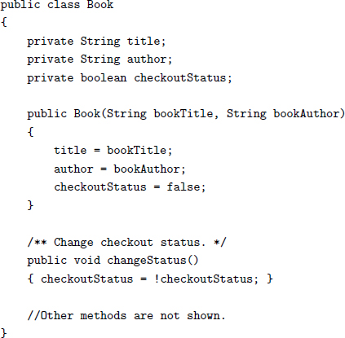
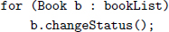
18.
Consider this class.
A client program has this declaration.
Book[] bookList = new Book[SOME_NUMBER];
Suppose
bookList
is initialized so that each
Book
in the list has a
title, author, and checkout status. The following piece of code is
written, whose intent is to change the checkout status of each book
in
bookList
.
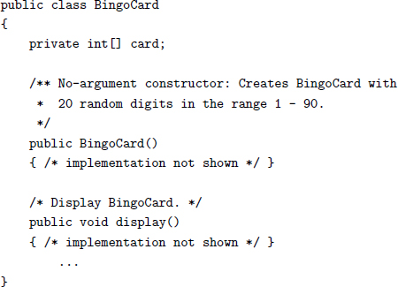
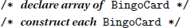
Which is true about this code?
(A)
The
bookList
array will remain unchanged after execution.
(B)
Each book in the
bookList
array will have its checkout
status changed, as intended.
(C)
A
NullPointerException
may occur.
(D)
A run-time error will occur because it is not possible to
modify objects using the enhanced
for
loop.
(E)
A logic error will occur because it is not possible to modify
objects in an array without accessing the indexes of the
objects.
Consider this class for Questions 19 and 20.
A program that simulates a bingo game declares an array of
BingoCard
. The
array has
NUMPLAYERS
elements, where each element represents the card of a
different player. Here is a code segment that creates all the bingo cards in
the game.
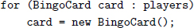
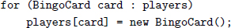
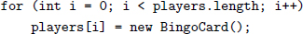
19.
Which of the following is a correct replacement for
/* declare array of BingoCard */?
(A)
int[] BingoCard = new BingoCard[NUMPLAYERS];
(B)
BingoCard[] players = new int[NUMPLAYERS];
(C)
BingoCard[] players = new BingoCard[20];
(D)
BingoCard[] players = new BingoCard[NUMPLAYERS];
(E)
int[] players = new BingoCard[NUMPLAYERS];
20.
Assuming that
players
has been declared as an array of
BingoCard
,
which replacement for
/*
construct each
BingoCard */
is correct?
I.
II.
III.
(A)
I only
(B)
II only
(C)
III only
(D)
I and III only
(E)
I, II, and III
Questions 21 and 22 refer to the
Deck
class described below.
A
Deck
class contains an array
cards
with an even number of
Card
values
and a
final
variable
NUMCARDS
, which is an odd integer.
21.
Here are two possible algorithms for shuffling the deck.
Algorithm 1
Initialize an array of
Card
called
shuffled
of length
NUMCARDS
.
Set
k
to
0
.
For
j=0
to
NUMCARDS/2-1
- Copy
cards[j]
to
shuffled[k]
- Set
k
to
k+2
Set
k
to
1
.
For
j=NUMCARDS/2
to
NUMCARDS-1
- Copy
cards[j]
to
shuffled[k]
- Set
k
to
k+2
Algorithm 2
Initialize an array of
Card
called
shuffled
containing
NUMCARDS
slots.
For
k=0
to
NUMCARDS-1
-
Repeatedly
generate
a
random
integer
j

from
0

to
NUMCARDS-1
,
until
cards[j]

contains
a
card
not
marked as empty
- Copy
cards[j]
to
shuffled[k]
- Set
cards[j]
to empty
Which is a false statement concerning Algorithms 1 and 2?
(A)
A disadvantage of Algorithm 1 is that it won’t generate all
possible deck permutations.
(B)
For Algorithm 2, to determine the last element shuffled
requires an average of
NUMCARDS
calls to the random number
generator.
(C)
Algorithm 2 will lead to more permutations of the deck than
Algorithm 1.
(D)
In terms of run time, Algorithm 2 is more efficient than
Algorithm 1.
(E)
If Algorithm 1 is repeated several times, it may return the
deck to its original state.
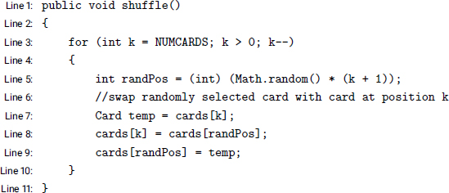
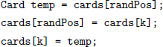
22.
The following
shuffle
method is used to shuffle the cards in the
Deck
class.
The method does not work as intended. Which of the following
changes should be made to correct the method?
(A)
Replace Line 3 with
for (int k = NUMCARDS; k >= 0; k--)
(B)
Replace Line 3 with
for (int k = NUMCARDS - 1; k > 0; k--)
(C)
Replace Line 3 with
for (int k = 1; k <= NUMCARDS; k++)
(D)
Replace Line 5 with
int randPos = (int) (Math.random() * k);
(E)
Replace Lines 7 – 9 with
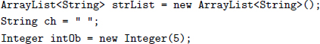
23.
Consider these declarations.
Which statement will cause an error?
(A)
strList.add(ch);
(B)
strList.add(new String("handy andy"));
(C)
strList.add(intOb.toString());
(D)
strList.add(ch + 8);
(E)
strList.add(intOb + 8);
24.
Let
list
be an
ArrayList<Integer>
containing these elements.
2 5 7 6 0 1
Which of the following statements would not cause an error to
occur? Assume
that
each
statement
applies
to
the
given
list,
independent of the other statements.
(A)
Object ob = list.get(6);
(B)
Integer intOb = list.add(3.4);
(C)
list.add(6, 9);
(D)
Object x = list.remove(6);
(E)
Object y = list.set(6, 8);
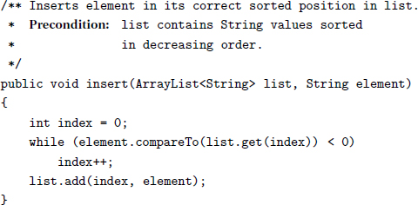
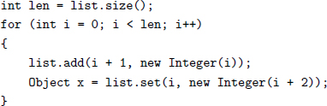
25.
Refer to method
insert
below.
Assuming that the type of
element
is compatible with the objects
in the list, which is a true statement about the
insert
method?
(A)
It works as intended for all values of
element
.
(B)
It fails for all values of
element
.
(C)
It fails if
element
is greater than the first item in
list
and
works in all other cases.
(D)
It fails if
element
is smaller than the last item in
list
and
works in all other cases.
(E)
It fails if
element
is either greater than the first item or
smaller than the last item in
list
and works in all other
cases.
26.
Consider
the
following
code
segment,
applied
to
list
,
an
ArrayList
of
Integer
values.
If
list
is initially
6 1 8
, what will it be following execution of the
code segment?
(A)
2 3 4 2 1 8
(B)
2 3 4 6 2 2 0 1 8
(C)
2 3 4 0 1 2
(D)
2 3 4 6 1 8
(E)
2 3 3 2
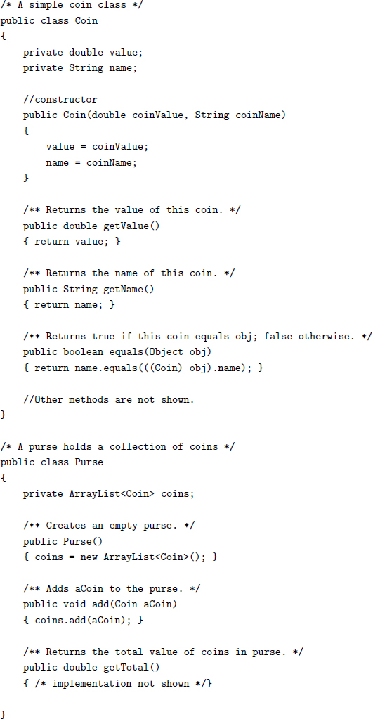
Questions 27 and 28 are based on the
Coin
and
Purse
classes given below.
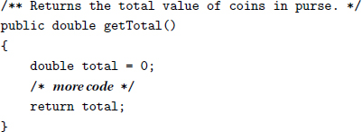
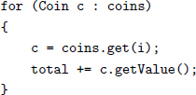
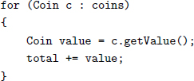
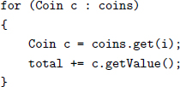
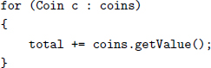
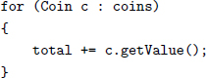
27.
Here is the
getTotal
method from the
Purse
class.
Which of the following is a correct replacement for
/*
more code
*/?
(A)
(B)
(C)
(D)
(E)
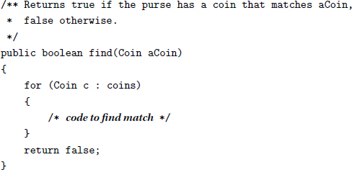
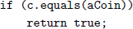
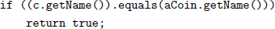
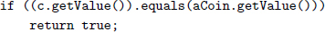
28.
Two coins are said to match each other if they have the same name
or the same value. You may assume that coins with the same name
have the same value and coins with the same value have the same
name. A boolean method
find
is added to the
Purse
class.
Which is a correct replacement for
/*
code to find match
*/?
I.
II.
III.
(A)
I only
(B)
II only
(C)
III only
(D)
I and II only
(E)
I, II, and III
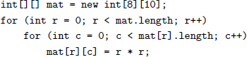
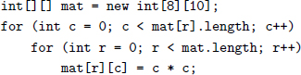
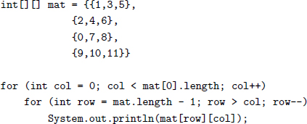
29.
Which of the following initializes an 8 × 10 matrix with integer
values that are perfect squares? (0 is a perfect square.)
I.
int[][] mat = new int[8][10];
II.
III.
(A)
I only
(B)
II only
(C)
III only
(D)
I and II only
(E)
I, II, and III
30.
Consider the following code segment.
When this code is executed, which will be the fifth element printed?
(A)
3
(B)
4
(C)
5
(D)
6
(E)
7
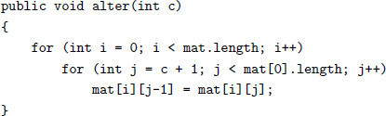
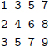
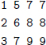
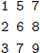
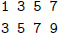
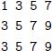
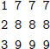
31.
Consider a class that has this private instance variable.
private int[][] mat;
The class has the following method,
alter
.
If a 3 × 4 matrix
mat
is
then
alter(1)
will change
mat
to
(A)
(B)
(C)
(D)
(E)
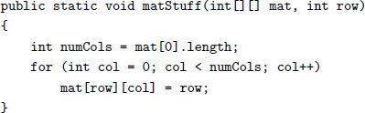
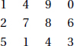
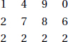
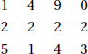
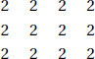
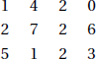
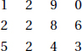
32.
Consider the following method that will alter the matrix
mat
.
Suppose
mat
is originally
After the method call
matStuff(mat,2)
, matrix
mat
will be
(A)
(B)
(C)
(D)
(E)
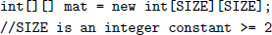
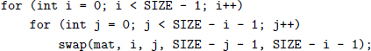
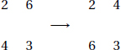
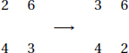
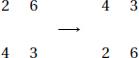
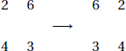
33.
Assume that a square matrix
mat
is defined by
What does the following code segment do?
You may assume the existence of this
swap
method.
(A)
Reflects
mat
through its major diagonal. For example,
(B)
Reflects
mat
through its minor diagonal. For example,
(C)
Reflects
mat
through a horizontal line of symmetry. For
example,
(D)
Reflects
mat

through
a
vertical
line
of
symmetry.
For
example,
(E)
Leaves
mat
unchanged.
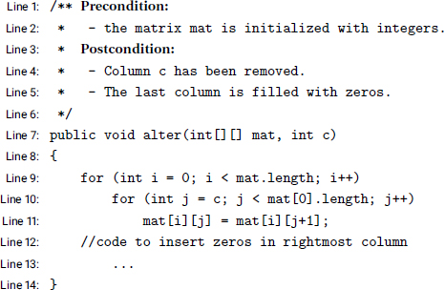
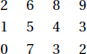
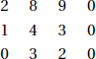
34.
Consider a class
MatrixStuff
that has a private instance variable.
private int[][] mat;
Refer to method
alter
below that occurs in the
MatrixStuff
class.
(The lines are numbered for reference.)
The intent of the method
alter
is to remove column
c
. Thus, if the
input matrix
mat
is
the method call
alter(mat, 1)
should change
mat
to
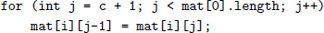
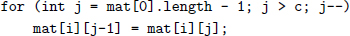
The method does not work as intended. Which of the following
changes will correct the problem?
I.
Change line 10 to
for (int j = c; j < mat[0].length - 1; j++)
and make no other changes.
II.
Change lines 10 and 11 to
and make no other changes.
III.
Change lines 10 and 11 to
and make no other changes.
(A)
I only
(B)
II only
(C)
III only
(D)
I and II only
(E)
I, II, and III
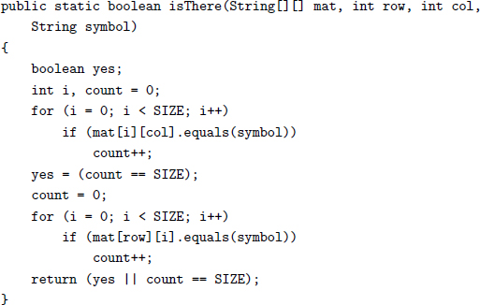
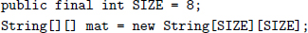
35.
This question refers to the following method.
Now consider this code segment.
Which of the following conditions on a matrix
mat
of the type
declared in the code segment will by itself guarantee that
isThere(mat, 2, 2, "$")
will have the value
true
when evaluated?
I.
The element in row 2 and column 2 is
"$"
.
II.
All elements in both diagonals are
"$"
.
III.
All elements in column 2 are
"$"
.
(A)
I only
(B)
III only
(C)
I and II only
(D)
I and III only
(E)
II and III only
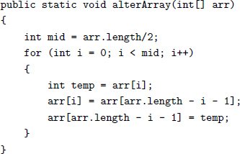
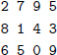
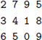
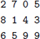
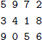
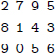
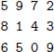
36.
Consider the following method.
If the current state of a matrix
mat
is
which
matrix
will
result
from
the
method
call
alterArray(mat[2])?
(A)
(B)
(C)
(D)
(E)
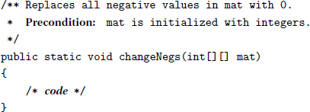
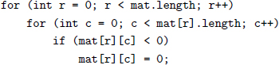
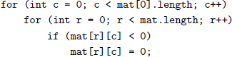
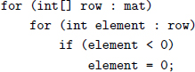
37.
The method
changeNegs
below should replace every occurrence of a
negative integer in its matrix parameter with 0.
Which is a correct replacement for
/*
code
*/?
I.
II.
III.
(A)
I only
(B)
II only
(C)
III only
(D)
I and II only
(E)
I, II, and III
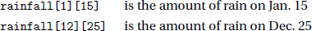
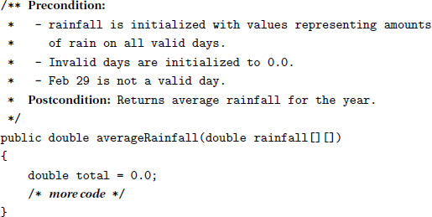
38.
A two-dimensional array
rainfall
that contains
double
values will
be used to represent the daily rainfall for a given year. In this
scheme,
rainfall[month][day]
represents the amount of rain on
the given day and month. For example,
The array can be declared as follows.
double[][] rainfall = new double[13][32];
This creates 13 rows indexed from
0
to
12
and 32 columns indexed
from
0
to
31
, all initialized to
0.0
. Row
0
and column
0
will be
ignored. Column
31
in row
4
will be ignored, since April 31 is not
a valid day. In years that are not leap years, columns
29, 30
, and
31
in row
2
will be ignored since Feb. 29, 30, and 31 are not valid
days.
Consider the method
averageRainfall
below.
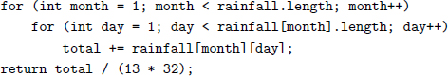
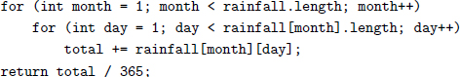
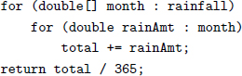
I.
II.
III.
(A)
None
(B)
I only
(C)
II only
(D)
III only
(E)
II and III only
Which of the following is a correct replacement for
/*
more code
*/
so that the postcondition for the method is satisfied?
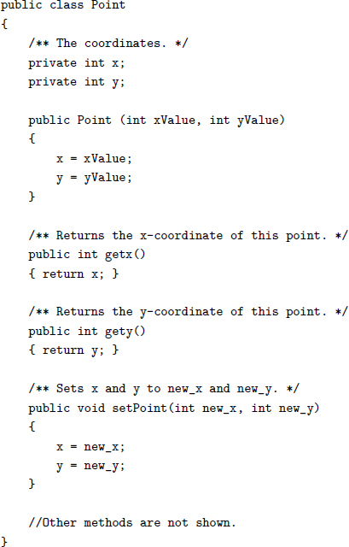
The method
changeNegs
below takes a matrix of
Point
objects as
parameter and replaces every
Point
that has at least one negative
coordinate with the
Point
(0,0).
39.
This question is based on the
Point
class below.
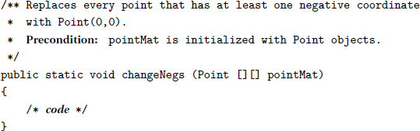
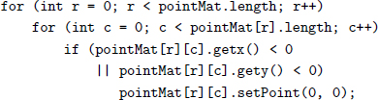
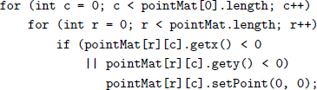
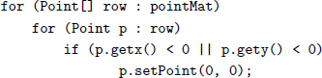
Which is a correct replacement for
/*
code
*/?
I.
II.
III.
(A)
I only
(B)
II only
(C)
III only
(D)
I and II only
(E)
I, II, and III
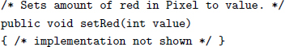
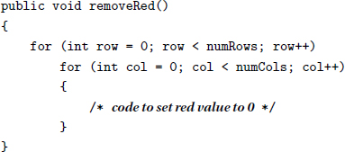
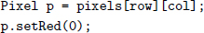
40.
A
Pixel
class has several mutator methods that allow the color of a
Pixel
to be changed. For example,
Consider a
Picture
class that has a private instance variable
pixels
, which is a 2D array of
Pixel
objects. There are also
int
variables
rows
and
cols
that contain the number of rows and
columns in the
pixels
array.
A method
removeRed
in the
Picture
class sets the red value of
every pixel to zero.
Which is a correct replacement for
/*
code to set red value to 0
*/?
I.
II.
pixels[row][col].setRed(0);
III.
pixels[row][col] = 0;
(A)
I only
(B)
II only
(C)
III only
(D)
I and II only
(E)
I, II, and III
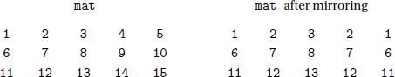
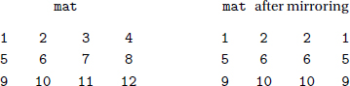
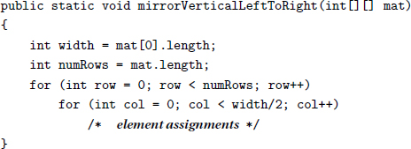
41.
Consider a class
MatrixStuff
that has a private instance variable
mat
.
private int[][] mat;
The following method uses a vertical mirror down the center of a
matrix to reflect the left half of the matrix onto the right. The
following
two
examples
show
the
result
of
mirroring
a
two-
dimensional array of numbers from left to right vertically. (Another
way of saying this is that the right half of the matrix is replaced by
a vertical mirror image of the left half.)
Example 1:
Example 2:
Which replacement for
/*
element assignments
*/
will make the
method work as intended?
(A)
mat[row][col] = mat[row][width - col];
(B)
mat[row][width - col] = mat[row][col];
(C)
mat[row][width - 1 - col] = mat[row][col];
(D)
mat[row][col] = mat[row][width - 1 - col];
(E)
mat[row][width - 1 - col] = mat[col][row];
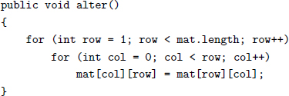
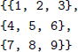
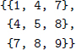
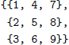
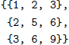
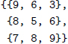
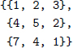
42.
Consider a square matrix in a class that has a private instance
variable
mat
.
private int[][] mat;
Method
alter
in the class changes
mat
.
If
mat
has current value
what
are
the
contents
of
mat

after
method
alter

has
been
executed?
(A)
(B)
(C)
(D)
(E)
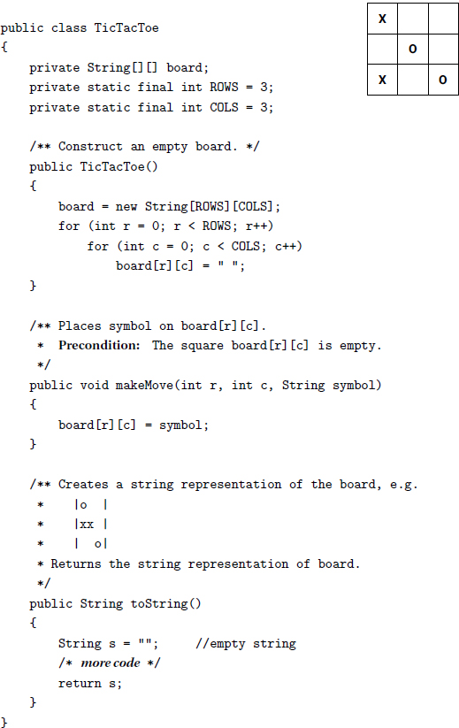
43.
A simple Tic-Tac-Toe board is a 3 × 3 array filled with either X’s,
O’s, or blanks. Here is a class for a game of Tic-Tac-Toe.
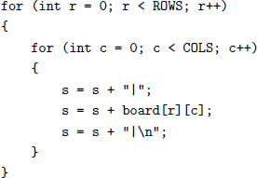
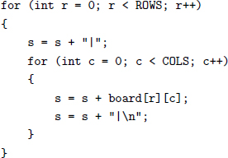
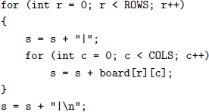
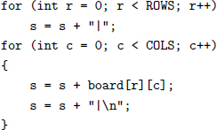
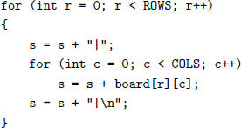
Which segment represents a correct replacement for
/*
more code
*/
for the
toString
method?
(A)
(B)
(C)
(D)
(E)

